Screenshot of dataset folder ( captured images are converted into greyscale and then stored)

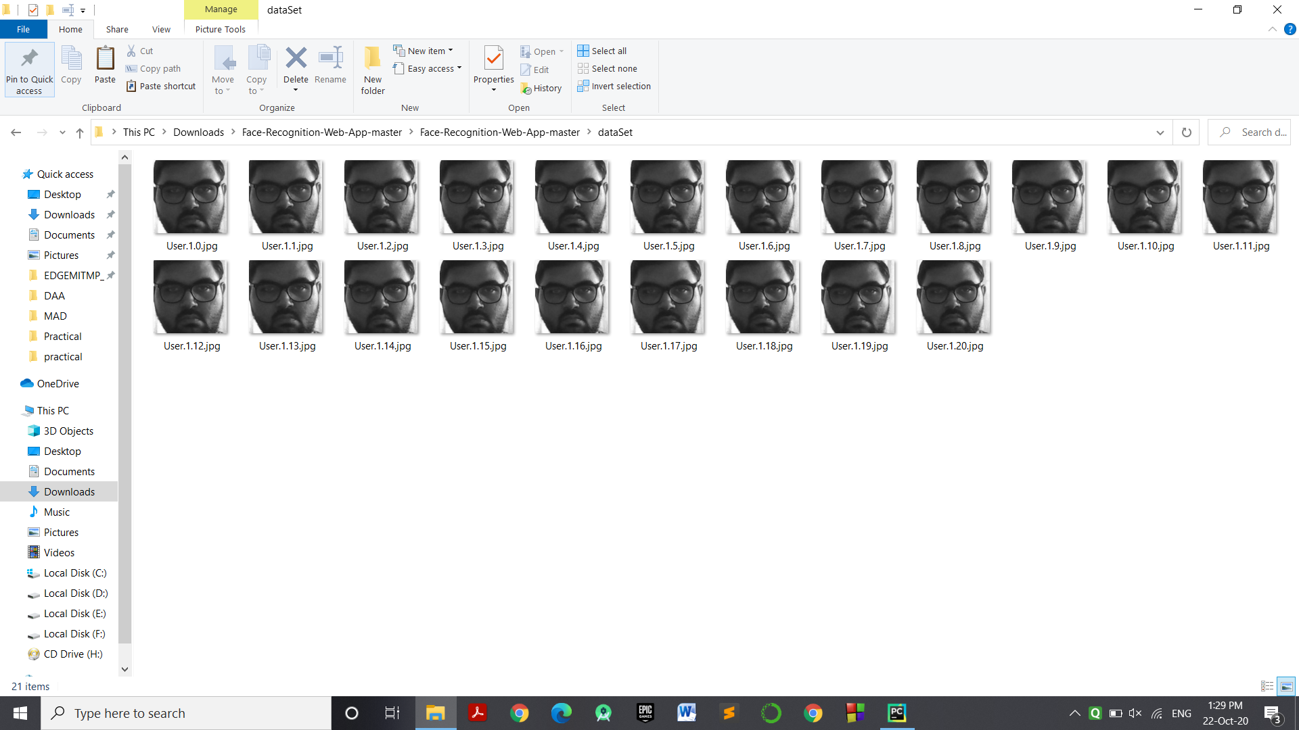

Face Training

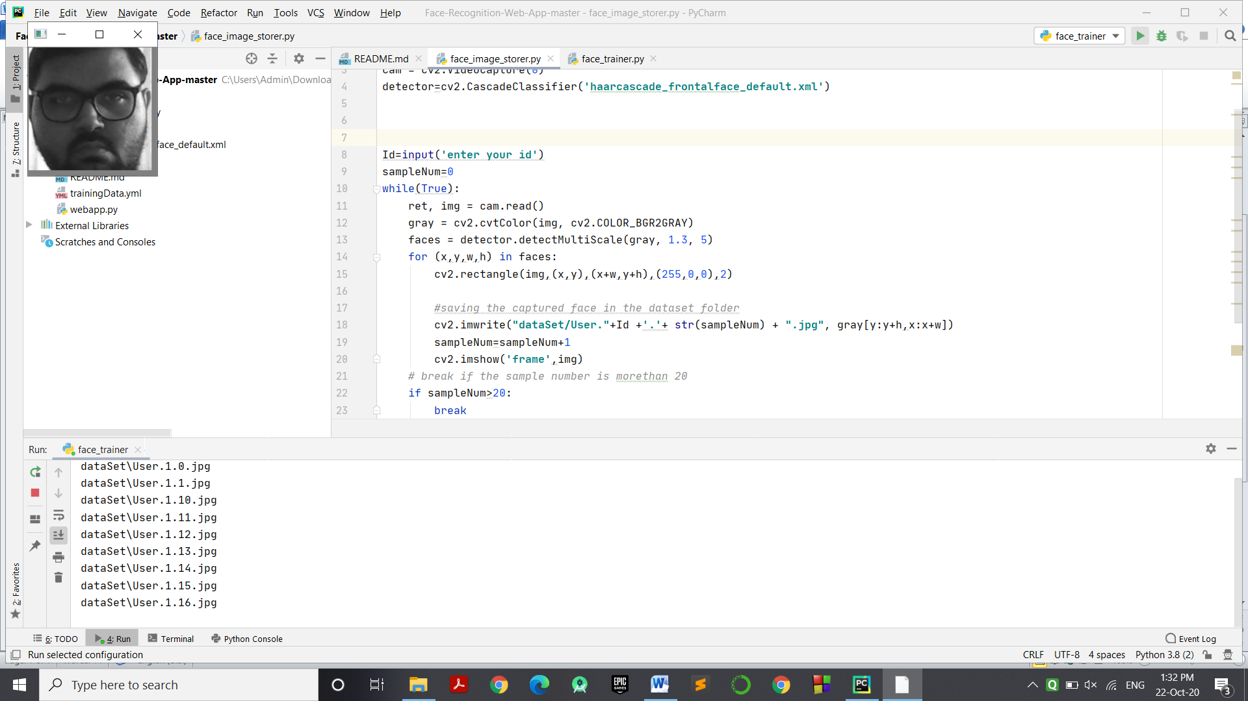

Webapp , Face is detected but not recognized so unknown.

